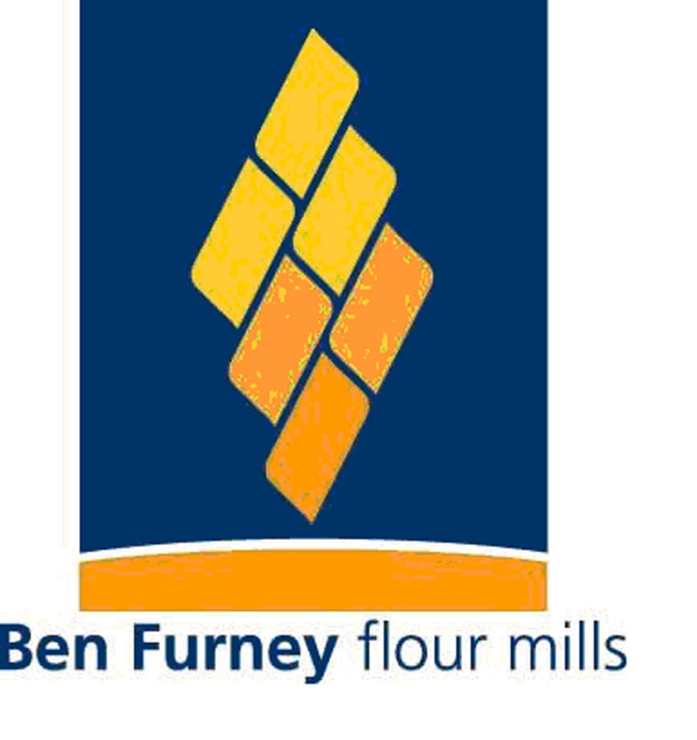
Beltavia Pty Limited

Pollution Incident Response Management Plan

Dubbo Mill Site – Brisbane Street Dubbo NSW 2830

Contents
1. INTRODUCTION ............................................... ..................................................................... 3
1.1 Background ........................................................................................................................ .. 3
1.2 Objectives ..................................................................................................................... ........ 3
2. SITE INFORMATION .......................................... .................................................................... 4
2.1 Site Details ..................................................................................................................... ....... 4
2.2 Surrounding Land Uses ......................................................................................................... 5
2.3 Surrounding Sensitive Environments ..................................................................................... 5
2.4 Neighbouring Properties ........................................................................................................ 5
2.5 Environmental Hazards .......................................................................................................... 6
2.6 Inventory of Pollutants ............................................................................................................ 7
3. PRE-EMPTIVE ACTIONS & CONTROL MEASURES .. .......................................................... 8
3.1 Health and Safety ................................................................................................................... 8
3.2 Pollution Control Measures ............................................................... ............. ...................... 8
3.3 Spill Response ..................................................................................... ....... ... ..................... 9
3.4 Drainage ............................................................................................................ .................... 9
3.5 Wastewater Treatment & Effluent System .......................................................... ................... 9
3.6 Surface Water Management Plan .......................................................... ............................... 9
4. MANAGEMENT AND RESPONSIBILITIES ...................... ...................................... .................. 10
4.1 Legal Duty to Notify ............................................................................................. ................ .10
4.2 Beltavia Management ............................................................................................................ 10
5. INCIDENT MANAGEMENT ......................................................................................................... 11
5.1 Determination of Material Harm ................................................................................ ........... 11
5.2 External Notification .............................................................................................................. 11
5.3 Community Communication ............................................................................................... 13
6. TRAINING AND TESTING ................................................... ................................................. 13
6.1 Training .............................................................................. ................................................ 13
6.2 Testing, review and Maintenance ....................................................................................... 13

1. INTRODUCTION

1.1 Background

Beltavia Pty Limited currently holds an Environmental protection license (EPL) (licence number 4979). The Licence is regulated by the NSW Environment Protection Authority (EPA) and is required under the Protection of the Environment Operations Act 1997 (POEO Act). There is a duty to report pollution incidents under section 148 of the POEO Act. In 2012, important changes have been made to the duty to notify provisions as a result of the Protection of the Environment Legislation Amendment Act 2011. Provisions include a requirement for holders of an EPL to prepare, keep, test and implement a Pollution Incident Response Management Plan (PIRMP). The Pollution Incident Response Management Plan must:

• Be kept at all times at the premises;

• Include information as required in the amendment;

• Be tested on an annual basis; and

• Be implemented if a pollution incident does occur.

This document has been developed to satisfy the PIRMP requirements documented above, and detail the procedures for notification of pollution incidents resulting in or having the potential to cause material harm to the environment. The notification of environmental incidents under this PIRMP is only required for those incidents causing or threatening to result in material environmental harm (a material harm incident) as defined in the POEO Act (See Section 5.1)

1.2 Objectives

The objectives of the pollution incident response management plan are to:

• Provide guidance on responding to a pollution incident, such that potential harm to the environment and humans is minimised; and

• Ensure timely and correct reporting of a pollution incident.

2. SITE INFORMATION

2.1 Site Details

Beltavia Pty Limited T/as Ben Furney Flour Mills is located at 101-105 Brisbane Street Dubbo NSW 2830

(See Figure 2.1& 2.1A).

Figure 2.1

Figure 2.1A

2.2 Surrounding Land Uses

Ben Furney Flour Mills is zoned in an Enterprise Corridor under the Dubbo City Council Local Environmental Plan 2011. Surrounding land use is a mixture of a Railway Infrastructure (line) and part of the Commercial Core of Dubbo and neighbours include a Mitre 10 store, untenanted office/retail space and a Escort Agency.

2.3 Surrounding Sensitive Environments

Ben Furney Flour Mills has no immediate surrounding sensitive environments.

Source: Google Earth Image 2012 Figure 2.1 & “.1A :Ben Furney Flour Mills Dubbo NSW.

Table 2.1 is a detailed list of the neighbouring properties, sourced from Ben Furney Flour Mills site copy of the Emergency Preparedness and Response Procedure (available in onsite PIRMP copy).

2.4 Neighbouring Properties

Table 2.1 includes contact names and numbers of those properties most likely to be effected in the event of a pollution incident (this table is available in the on-site version of the PIRMP).

Brennan’s Mitre 10 Ph: 02 6882 6133
Louise’s Escort Agency Ph: 02 6882 9811
Hebla Pty Ltd Ph: 0417 664 568
Dubbo Ag & General Ph: 02 6882 4731
Village Hot Bake Ph: 02 6884 5454

2.5 Environmental Hazards

The potential major hazards which have been identified for Ben Furney Flour Mills are listed in Table 2.2 below. The likelihood of these potential hazards occurring has been captured using the methodology defined in Table 2.3. Site will simultaneously refer to Ben Furney Flour Mills Risk Management Procedure. The purpose of this procedure is establish, implement and maintain a risk management program to facilitate the associated risks and the elimination or control of risks to as low as reasonably practical and the review of control measures. It covers all activities carried out on Ben Furney Flour Mills site.

Table 2.2: Hazards and their likelihood
HAZARD | HAZARDOUS EVENT | LIKELIHOOD | EVENTS THAT COULD INCREASE LIKELIHOOD
Chemicals | Hazardous Chemical Leak/spill | Unlikely | Natural disaster; Bunding damaged
Diesel/ Unleaded Fuel | Tank/ bottle leak | Unlikely | Gas line / valves damaged or punctured; fire; Bunding damaged
Natural Gas | Natural Gas Leak | Unlikely | Natural disaster; Gas line / valves damaged or punctured
Workshop/Waste oil  Chlorine Gas  Product Flour/Offal | Spill  Bottle Leak  Spill | Unlikely  Unlikely  Likely | Storage or Bunding Damage  Natural disaster  Storage Damage, Packing failure, Product Transfer Pipe failure

Table 2.3: Methodology used to determine likelihood
LIKELIHOOD | DESCRIPTION
Almost Certain | Most Likely to occur
Very Likely | Could Occur Frequently
Likely | Could Occur Occasionally
Unlikely | Could Occur but unlikely
Very Unlikely | Has never happened but is possible
Very Rare | Not known to have ever happened anywhere

2.6 Inventory of Pollutants

All chemicals at Ben Furney Flour Mills are included in the hazardous substance and dangerous goods register This register is available on site as a part of procedure Dangerous Goods, Hazardous Substances and Chemicals. All chemicals are accompanied by the relevant Material Safety Data Sheets as required by work, health and safety regulations. The facilities that store hazardous chemicals have been designed in accordance with Australian Standards.

3. PRE-EMPTIVE ACTIONS & CONTROL MEASURES

3.1 Health and Safety

Before responding to a pollution incident, health and safety risks are to be identified and assessed by Ben Furney Flour Mills Managers. If the site is required to be evacuated as a result of a pollution event, evacuation procedures and muster points are detailed in the Emergency Plan.

3.2 Pollution Control Measures

Preventative and mitigation controls established at Ben Furney Flour Mill are detailed below:

Pre-emptive Action

Spill containment kits located in appropriately designated areas

Line marking; Isolation valves; grounds maintained; extinguishers present

3.3 Spill Response

This will be organised by the Manager on site at the time.

3.4 Drainage

Stormwater drains are located around the perimeter of the building for collection of rainwater from the plants roof. Stormwater pits are also incorporated into hard surfaces areas e.g. roadways and car park for collection of rainwater. Stormwater from Site directly feeds to Dubbo City Council Stormwater Drainage System.

3.5 Wastewater Treatment & Effluent System

A number of wastewater streams are generated at the site, including:

• Wash water from cleaning the plant

• Domestic wastewater from office and amenities;

The wastewater treatment system comprises a dissolved air flotation unit (DAF) which treats wastewater to a very high quality prior to discharge to sewer.

3.6 Surface Water Management Plan
The occurrence of surface water from environmental aspects i.e. storms, heavy rain etc and from disbursement of water from other sources such as burst water mains, flooding poses a risk of pollution by the business to the environment. As such the company in the event of an occurrence of a surface water event will immediately investigate and attend to any potential environmental issues that are within its control.

- Refer PIRMP
- Investigate area of spillage
- Implement action plan to rectify
- Advise regulatory bodies accordingly
- Follow up completion of actions
- Consult with staff on any corrective actions undertaken or procedural aspects that may need to be modified as a result of changes resulting from a surface water incident

4. MANAGEMENT AND RESPONSIBILITIES

4.1 Legal Duty to Notify

All Ben Furney Flour Mills employees are responsible for alerting management personnel to all environmental Incidents or hazards which may result in an environmental incident, regardless of the nature or scale. The responsibility to notify EPA and other agencies is detailed in the POEO Act (Section 148), which encompasses all site personnel, including contractors and sub-contractors.

4.2 Ben Furney Flour Mills Management

The Operation& Services Manager is accountable for the specific responsibilities associated with the management and implementation of the PIRMP for Ben Furney Flour Mills. The Operation& Services Manager will ensure the following actions are carried out:

• Assess the damage and recommend appropriate clean up and/or quarantine measures

• Appoint an appropriately qualified personnel to carry out clean up

• Advise the Executive Team, QA Manager & Mill Manager

• Complete the incident Report Form and send a copy to the above Team & Managers

The Operation& Services Manager will converse with and be supported by the following Management personnel as required:

• CEO

• COO

• CFO

• QA Manager

5. INCIDENT MANAGEMENT

A pollution incident is defined in the POEO Act as an incident or set of circumstances during or as a consequence of which there is likely to be a leak, spill or other escape or deposit of a substance, as a result of which pollution has occurred, is occurring or is likely to occur. It includes an incident or set of circumstances in which a substance has been placed or disposed of on premises, but it does not include an incident or set of circumstances involving only the emission of any noise. In the case of an environmental incident, prior to any action, the site must contact 000 if the incident presents an immediate threat to human health or property. Fire and Rescue NSW, the NSW Police and the NSW Ambulance Service are the first responders, as they are responsible for controlling and containing incidents. If the incident does not pose any threat to human health or property, concurrently with contacting 000, all possible actions should be taken to control the pollution incident and minimise health, safety and environmental consequences. Arrangements, including description and location of safety equipment, for minimising risk of harm to people and the environment as a result of a pollution incident, and or containing or controlling a pollution incident, are included in the following documentations: Ben Furney Flour Mills Procedure Incident Reporting Investigation.

5.1 Determination of Material Harm

Following containment of an incident, immediate action must be taken to determine if the incident can be classified as a ‘material harm incident’ i.e. considered to be causing or threatening material harm. As defined by Section 147 of POEO Act, a material harm incident has occurred if the incident;

• Involves actual or potential harm to the health or safety of human beings or to ecosystems that is not trivial; or

• Results in actual or potential loss (including all reasonable costs and expenses that would be incurred in taking all reasonable and practicable measures to prevent, mitigate or make good harm to the environment) or property damage of an amount, or amounts in aggregate, exceeding $10,000 (or such other amount as is prescribed by the regulations).

The determination of a material harm incident will be made by the appropriate management personnel.

5.2 External Notification

As discussed in Section 4.1, notification of an environmental incident is the responsibility of all site and contractor personnel. In the instance of identification of an environmental incident, the personnel will report the issue immediately to their manager, who will follow the table 5.1 Ben Furney Flour Mills Group incident reporting procedures in accordance with EPA requirements. Immediately is taken to mean ‘promptly and without delay’. As per guidance provided by the EPA, the decision on whether to notify the incident in accordance with Part 5.7 of the POEP Act should not delay immediate actions to provide the safety of people or contain a pollution incident. However, incident notification will be made as soon as it is safe to do so. The agencies listed in Table 5.1 must be contacted in the order outlined below:

Table 5.1 PIRMP Notification Requirements

 | CONTACT DETAILS
Emergency Hotline Number (24 Hours) | 000*
Ben Furney Flour Mills  Garry Stewart  Tim Furney  Linden Kotzur  AGENCY | 0408 294 469  0417 664 568  0418 638 351
Environment Protection Authority (EPA)  Dubbo Regional Office  Emergency Hotline Number (24 hours) | 02 6883 5330  131 555
NSW Ministry of Health (via Public Health Units)  Dubbo Regional Office  Public Health Officer on Call (24 hours) | 02 6841 5569  0418 866 397
Workcover NSW | 131 050
Dubbo City Council (24 hours) | 02 6801 4000

*only to be contacted first if fire or rescue services are required, otherwise contact last. In addition to being detailed in this document, procedures for undertaking internal and external notifications are included in: Ben Furney Flour Mills Procedure Incident Reporting Investigation. Record keeping of incident details, including investigations and outcomes, will be undertaken in accordance with this procedure. After initial notification of any material harm incident, it will be the responsibility of the COO – Tim Furney to liaise with any authority listed in Table 5.1 that requests additional information, or is providing directions for management of the material harm incident. This may include incident investigation reports and ongoing environmental monitoring results.

5.3 Community Communication

In the event of a pollution incident that has the potential to affect surrounding neighbours, Ben Furney Flour Mills will contact neighbours as required according to the Site Emergency Plan Procedures.

6. TRAINING AND TESTING

6.1 Training

All personnel affected by the content of this document will receive instruction or explanation on the relevant parts of the document. Incident management and emergency response shall be included in all Ben Furney Flour Mills inductions.

6.2 Testing, review and Maintenance

The testing of the PIRMP will be undertaken to check that the information is accurate and current and that the plan is capable of being implemented in a workable and effective manner. Testing shall be undertaken in the following ways:

1. The PIRMP will be tested by assessing and reviewing it and making any necessary changes as identified. Testing is taken to be either a desktop review or an environmental emergency drill procedure. Testing will include all components of the plan, including training requirements;

2. A review of the PIRMP will occur every 12 months commencing from the date of authorisation by Ben Furney Flour Mills. Contact details in this document must be keep current at all times; and

3. The PIRMP will be reviewed within one month from the date of any pollution incident that occurs in the course of an activity to which the EPL relates. This review will be undertaken in light of the incident, to provide the information included in the plan is accurate and up to date and the plan is still capable of being implemented in a workable and effective manner.

Records will be kept in accordance with Ben Furney Flour Mills Records and Records Management Procedure and will be included in this plan. Information to be retained regarding PIRMP testing included:

• The manner in which the test was undertaken;

• Dates when the plan has been tested;

• The person who carried out the testing; and

• The date and description of any update of or amendment to the plan.

